**Lab assignment 1**

**Rushang bagada u24cs076**

**Q1:**

**<html><head>**

**<title>web2</title>**

**<style type="text/css">**

**body {**

**font-style: normal;**

**color:rgb(255, 255, 255);**

**font-weight: normal;**

**text-align: center;**

**background-color: #1f1f1f;**

**}**

**</style>**

**</head><body>**

**<form method="post" action="register.html" name="register">**

**<table style="text-align: left; width: 1161px; height: 310px;" border="0" cellpadding="2" cellspacing="2">**

**<tbody>**

**<tr>**

**<td style="vertical-align: top; font-family: Candara; text-align: center;">Name:**

**</td>**

**<td style="vertical-align: top;"><input name="name"><br>**

**</td>**

**</tr>**

**<tr>**

**<td style="vertical-align: top; font-family: Candara; text-align: center;">Student**

**</td>**

**<td style="vertical-align: top;"><input name="id"><br>**

**</td>**

**</tr>**

**<tr style="font-family: Candara;" align="center">**

**<td style="vertical-align: top; font-family: Candara; text-align: center;">Studying**

**</td>**

**<td style="vertical-align: top; text-align: left;"><font size="+1"><span style="font-family: Candara;">1</span><sup style="font-family: Candara;">st</sup><span style="font-family: monospace;"></span></font><input name="Year" value="1" type="radio"> <span style="font-family: monospace;"></span><big><big><small>2<small><sup>nd</sup></small></small></big></big><input name="Year" value="2" type="radio"> <big>3<small><sup>rd</sup></small></big>**

**<input name="Year" value="3" type="radio"> 4<sup>th</sup> <input name="Year" value="4" type="radio"><br>**

**</td>**

**</tr>**

**<tr>**

**<td style="vertical-align: top; font-family: Candara; text-align: center;">Semester:**

**</td>**

**<td style="vertical-align: top;"><span style="font-family: Candara;">Even <input name="sem" value="even" type="radio"></span> Odd <input name="sem" value="odd" type="radio"><br>**

**</td>**

**</tr>**

**<tr>**

**<td style="vertical-align: top; text-align: center;"><span style="font-family: Candara;">Hosteller: -</span><br>**

**</td>**

**<td style="vertical-align: top;">Yes <input name="H1" value="yes" type="radio"> No <input name="H1" value="no" type="radio"><br>**

**</td>**

**</tr>**

**<tr>**

**<td style="vertical-align: top;"><br>**

**</td>**

**<td style="vertical-align: top;"><input value="submit" name="submit" type="submit"> <input name="reset" value="reset" type="reset"><br>**

**</td>**

**</tr>**

**</tbody>**

**</table>**

**</form>**

**</body></html>**

**Output:-**

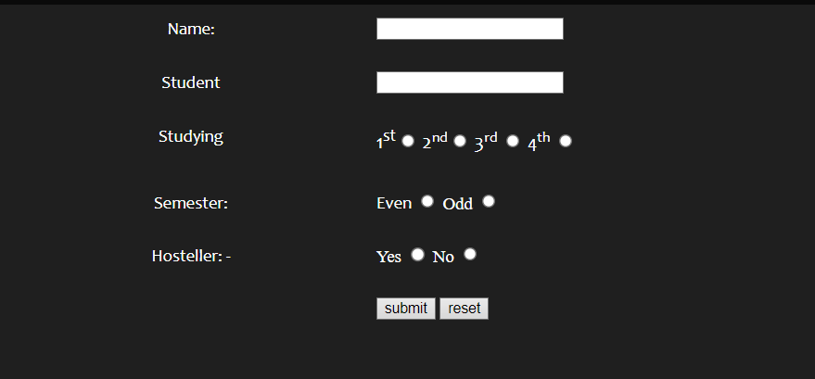

**Q2:**

**<!DOCTYPE html>**

**<html lang="en">**

**<head>**

**<title>class 1</title>**

**<style>**

**h1 {**

**font-family: 'Courier New', Courier, monospace;**

**color: red;**

**font-size: 50px;**

**text-align: center;**

**padding: 0px;**

**}**

**a {**

**display: flex;**

**flex-direction: column;**

**color: rgb(13, 187, 210);**

**text-align: center;**

**font-family: 'Gill Sans', 'Gill Sans MT', Calibri, 'Trebuchet MS', sans-serif;**

**}**

**body {**

**background-color: rgb(46, 6, 221);**

**display: flex;**

**align-items: center;**

**justify-content: center;**

**height: 100vh;**

**}**

**div {**

**align-items: center;**

**justify-items: center;**

**height: fit-content;**

**max-width: 600px;**

**background-color: #1f1f1f;**

**border-radius: 5px;**

**box-shadow: 0px 0px 5px 0px rgba(3, 255, 247, 0.75),**

**0px 0px 7px 0px rgba(5, 151, 147, 0.75);**

**}**

**p{**

**color: tan;**

**font-family: 'Gill Sans', 'Gill Sans MT', Calibri, 'Trebuchet MS', sans-serif;**

**padding: 10px;**

**}**

**</style>**

**</head>**

**<body>**

**<div>**

**<h1>hello world!</h1>**

**<a href="http://www.google.com">GO TO GOOGLE</a>**

**<a href="http://www.youtube.com">GO TO YOUTUBE</a>**

**<p>Lorem ipsum dolor sit amet consectetur adipisicing elit. Deleniti labore, fugit quam eaque molestiae eveniet**

**iusto**

**mollitia officia dolore dolorem provident ducimus voluptas a id similique quaerat earum suscipit ad**

**repudiandae**

**incidunt quidem, veritatis quasi fuga! Maiores adipisci repellendus dicta modi culpa vel molestias sit**

**ducimus hic**

**ut soluta distinctio quis nobis, explicabo sequi neque doloribus dignissimos nam ad quaerat? Vitae,**

**consectetur**

**tempore facilis deleniti aliquam adipisci voluptate tempora dolor possimus officia aliquid sed unde ipsa**

**sunt**

**excepturi maiores, rem, tenetur et ut hic neque. Id, ea qui culpa eius magni expedita soluta debitis**

**suscipit**

**voluptatibus saepe, optio tenetur? Id.</p>**

**</div>**

**</body>**

**</html>**

**Output:-**

